Emergencies and Utility Service Faults and Damages Report

2.0. CHAPTER 2: LITERATURE REVIEW

2.1. Introduction
This chapter presents a comprehensive review of existing literature related to the design and implementation of mobile-based systems for emergency reporting and utility service fault management. The purpose of this chapter is to examine relevant theories, technologies, and previously developed systems that provide a foundation for the proposed mobile application. It explores how advancements in mobile computing, geolocation technologies, and cloud-based systems have contributed to improving communication and response efficiency in emergency situations (Smith & Johnson, 2021; Hasan & Khan, 2022).
The chapter begins by discussing the concept of emergency management and the importance of timely reporting in reducing risks to life and property. It further examines the role of Information and Communication Technology (ICT) in enhancing public service delivery, particularly in the context of developing countries where traditional reporting methods are often inefficient (Yeboah & Boateng, 2022). Emphasis is placed on mobile applications as accessible tools for real-time data collection, communication, and coordination between users and service providers.
In addition, this chapter reviews existing mobile emergency reporting systems and related applications, analyzing their features, strengths, and limitations. These systems provide valuable insights into design approaches, system architecture, and user interaction models that inform the development of the proposed solution. The review also highlights the integration of technologies such as Global Positioning System (GPS), Application Programming Interfaces (APIs), and cloud computing in enabling accurate location tracking, efficient data transmission, and scalable system performance (Zhang et al., 2021; Smith & Chen, 2021).
Furthermore, the chapter identifies gaps in existing systems, particularly in relation to usability, accessibility, and adaptation to local contexts such as the Eastern Region of Ghana. These gaps justify the need for the proposed system and guide the selection of appropriate technologies and design methodologies. Overall, this literature review establishes the theoretical and practical basis for the study and provides direction for the system design and implementation discussed in subsequent chapters.

2.2 Review of System 1: PulsePoint Respond (Mobile Emergency Alert App)

2.2.1. Description of the System

2.2.1.1. Overview of the System
PulsePoint Respond is a mobile-based emergency notification system designed to connect the public directly with emergency services in real time. The application is integrated with emergency dispatch systems, enabling it to receive live data about ongoing incidents such as cardiac arrests, fires, and other critical emergencies (PulsePoint Foundation, 2023). Once an incident is recorded by dispatch services, the system sends alerts to nearby registered users, particularly those trained in life-saving techniques such as CPR. This approach enhances community participation in emergency response before professional responders arrive.
The system leverages geolocation technology to identify users within a certain radius of an incident and notify them instantly. It also provides a map-based interface that displays the exact location of the emergency, nearby automated external defibrillators (AEDs), and the movement of emergency responders where applicable. By reducing the delay between incident occurrence and response, the system contributes significantly to improving survival rates in time-sensitive emergencies (Smith & Chen, 2021).

2.2.1.2. Context Diagram for PulsePoint Respond

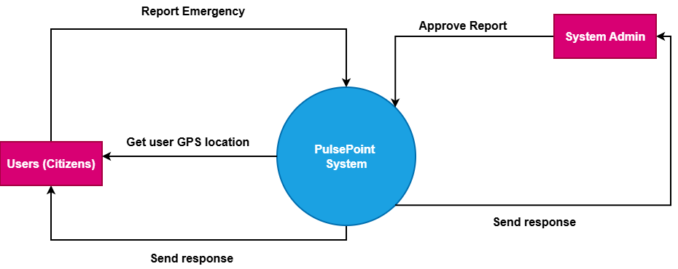
Figure 2.1
The context diagram for PulsePoint Respond presents a high-level view of the system and its interaction with external entities. The central system is the PulsePoint platform, which consists of the mobile application and backend server. It acts as an intermediary between users (citizens), emergency dispatch systems, and location-based services such as GPS and mapping APIs. The system receives real-time incident data from emergency dispatch centers and processes it for distribution.
Users interact with the system by receiving alerts and viewing incident details, while emergency responders benefit indirectly through improved community awareness and faster intervention. The GPS/Maps API provides location data that enables accurate identification of nearby users and visualization of incidents on a map. This interaction ensures that alerts are relevant and geographically targeted.
The diagram clearly defines the system boundary and shows that all communication between entities flows through the PulsePoint system. External systems do not interact directly with each other, which simplifies control, improves security, and ensures proper data management within the application.

2.2.1.3. Use Case Diagram for PulsePoint Respond

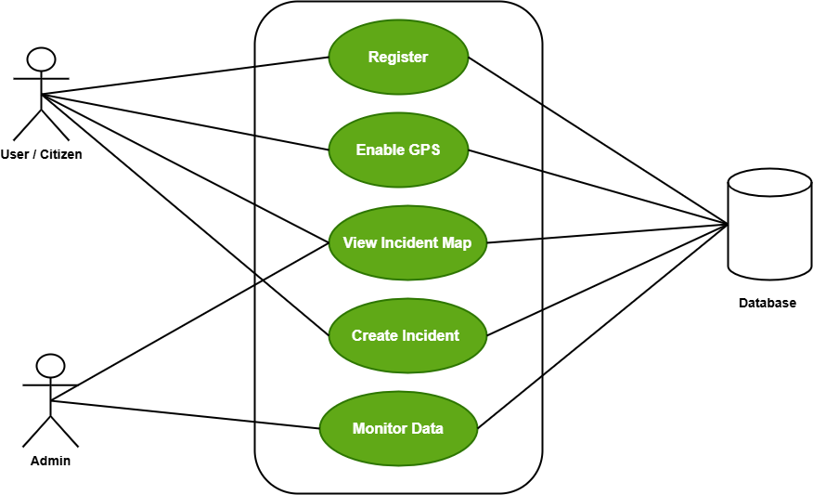
Figure 2.2
The use case diagram illustrates the functional interactions between the actors and the PulsePoint system. The primary actor is the user (citizen), who interacts with the system by registering, enabling location services, receiving alerts, and viewing incident details. These actions define the user’s role in responding to emergencies and staying informed.
The emergency dispatch center acts as another key actor, responsible for creating and updating incident data. These actions trigger the core functionality of the system, as alerts are generated based on dispatch inputs. Without this actor, the system would not have real-time data to distribute.
The administrator manages the system by ensuring smooth operation, monitoring data flow, and maintaining system integrity. The diagram highlights how different actors contribute to the overall functionality of the system and how use cases are interconnected to support real-time emergency communication.

2.2.1.4. Sequence Diagram for PulsePoint Respond

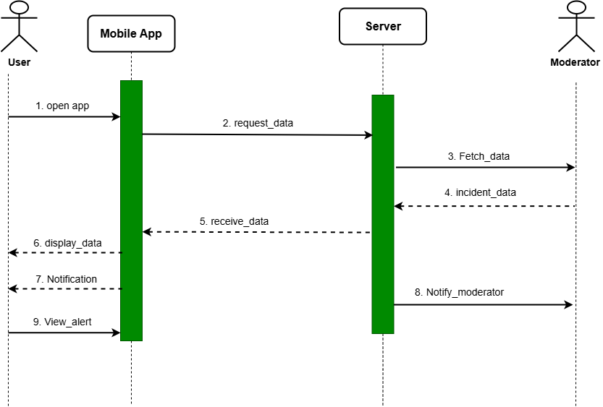
Figure 2.3
The sequence diagram describes the step-by-step interaction between system components during an emergency notification process. It begins when an incident is recorded in the emergency dispatch system. This data is sent to the PulsePoint server, where it is processed and prepared for distribution to users based on their geographic location.
The server communicates with the mobile application by sending notifications to users who are within the affected area. The mobile application receives the alert and displays relevant details such as the type of emergency and its location. This ensures that users are informed in real time and can take appropriate action if necessary.
The sequence also shows how the user interacts with the system after receiving the alert. The user opens the application, views the incident, and may locate nearby resources such as AEDs. This interaction flow highlights the efficiency of real-time communication between dispatch systems, servers, and end users.

2.2.1.5. Features of the System
PulsePoint Respond provides real-time emergency notifications to users based on their geographic proximity to incidents, enabling rapid awareness and potential intervention in critical situations. The system integrates GPS technology to ensure accurate location tracking and displays incidents on an interactive map interface for easy visualization.
The application includes features such as automatic alert generation from dispatch systems, identification of nearby life-saving equipment like AEDs, and continuous updates on emergency events. It also supports role-based functionality by distinguishing between general users and trained responders, ensuring that alerts are relevant and actionable.
Additionally, the system enhances community engagement by allowing citizens to play an active role in emergency response. This feature not only improves response times but also strengthens collaboration between the public and emergency service providers (Lamothe et al., 2021).

2.2.1.6. Development Tools and Development Environment of the System
PulsePoint Respond is developed using modern mobile application technologies that support both Android and iOS platforms, ensuring wide accessibility. The system relies on robust backend infrastructure to handle real-time data processing, integration with emergency dispatch systems, and delivery of push notifications.
The development environment includes the use of cloud-based servers, APIs for communication with external systems, and mapping technologies for geolocation services. These tools enable efficient data handling, scalability, and seamless integration with third-party services such as emergency dispatch centers and mapping providers.
Furthermore, the system employs secure communication protocols and high-availability server architecture to ensure reliability during critical situations. The use of scalable cloud infrastructure allows the system to handle large volumes of users and real-time data without performance degradation.

2.2.2. Review of the Good Features
PulsePoint Respond demonstrates several strengths, particularly in its ability to deliver real-time emergency alerts directly from official dispatch systems to users. This integration ensures high accuracy and reliability of information, reducing misinformation and enabling users to respond appropriately.
The use of geolocation technology significantly enhances the system’s effectiveness by targeting users within a specific radius of an incident. This location-based approach ensures that alerts are relevant and actionable, thereby improving response efficiency and community involvement.
Another notable advantage is the system’s ability to promote public participation in emergency response. By notifying trained individuals nearby, the application bridges the gap between incident occurrence and professional response, potentially saving lives in critical situations (Adeyemi & Salami, 2021).

2.2.3. Review of the Bad Features
Despite its strengths, PulsePoint Respond has limitations that may affect its applicability in certain contexts. One major limitation is its dependence on integration with advanced emergency dispatch systems, which may not be readily available in developing regions such as parts of Ghana.
The system also relies heavily on stable internet connectivity and smartphone availability, which can limit accessibility for users in rural or underserved areas. This dependency may reduce the overall effectiveness of the system in regions with poor network infrastructure.
Additionally, the application primarily focuses on emergency alerts rather than allowing users to actively report incidents. This lack of user-generated reporting functionality limits its usefulness in scenarios where community members need to initiate emergency communication (Alshamaila et al., 2021).

2.2.4. Summary of the System Review
In summary, PulsePoint Respond is an effective mobile-based emergency alert system that enhances real-time communication between emergency dispatch centers and the public. Its integration with official emergency services, combined with geolocation capabilities, makes it a powerful tool for improving response times and public safety.
However, the system’s reliance on advanced infrastructure and limited support for user-generated reporting highlights gaps that must be addressed when designing solutions for developing regions. These limitations emphasize the need for a more flexible and accessible system tailored to local contexts.
The insights gained from this system review provide valuable guidance for the proposed project, particularly in incorporating real-time notifications, geolocation tracking, and user engagement features while addressing challenges related to accessibility and infrastructure.

2.3 Review of System 1: Citizen Mobile Safety App

2.3.1. Description of the System

2.3.1.1. Overview of the System
Citizen is a mobile-based public safety application designed to provide users with real-time information about incidents occurring in their surroundings. The system aggregates data from official sources such as emergency services, as well as user-generated reports, to deliver timely alerts on events such as crimes, fires, accidents, and other safety-related incidents (Citizen App, 2023). The application emphasizes community awareness by allowing users to stay informed about potential threats in their locality.
The system uses geolocation technology to tailor alerts based on the user’s current location, ensuring that notifications are relevant and context-specific. It also incorporates multimedia features such as live video streaming and user-submitted content, enabling real-time sharing of incident details. This enhances situational awareness and allows users to make informed decisions regarding their safety (Khan & Rahman, 2021).

2.3.1.2. Context Diagram for Citizen Mobile Safety App

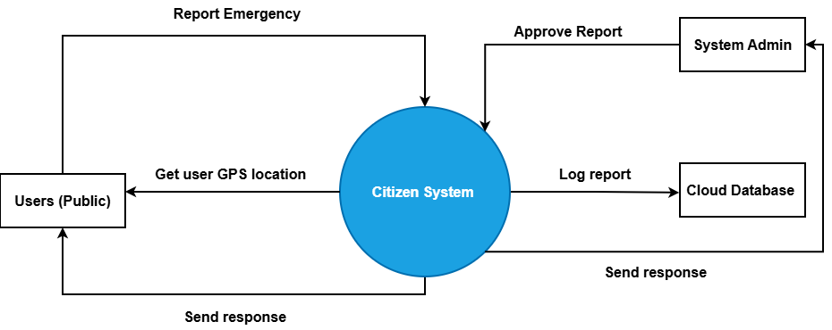 Figure 2.4
The context diagram for the Citizen Mobile Safety App shows how the system interacts with external entities such as users, emergency services, GPS/location services, and content moderators. The central system acts as a hub that collects, processes, and distributes safety-related information. Emergency services provide verified incident data, while users contribute additional reports and multimedia content.
The system also interacts with GPS and mapping services to determine user location and display incidents geographically. Content moderators play a role in verifying and filtering user-generated content to reduce misinformation before it is broadcast to other users. This ensures that the information shared within the system maintains a level of reliability.
The diagram emphasizes that all communication flows through the Citizen system, which processes incoming data and distributes alerts. This centralized approach ensures efficient data handling and consistent communication between all participating entities.

2.3.1.3. Use Case Diagram for Citizen Mobile Safety App

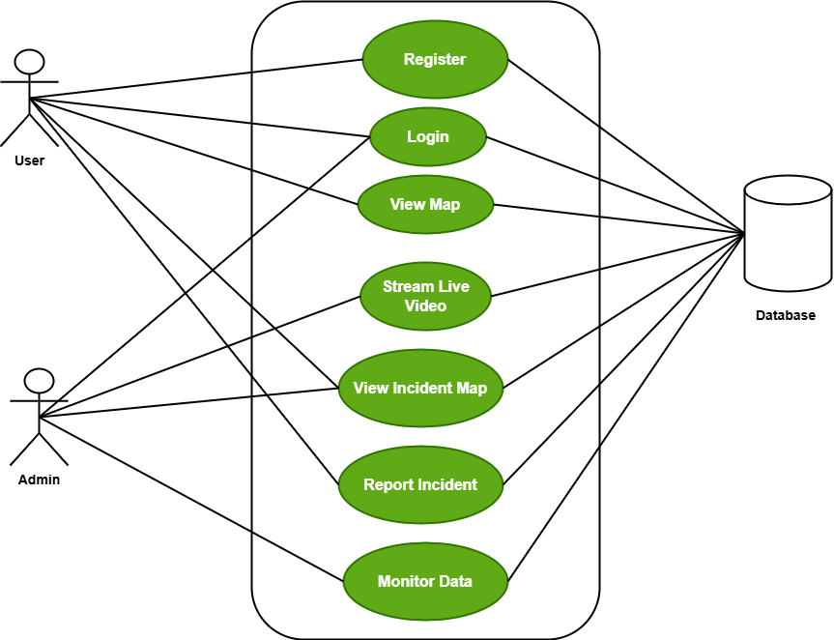 Figure 2.5

The use case diagram illustrates the different actors interacting with the Citizen system and the services they access. The primary actor is the user, who can register, log in, receive alerts, view incident locations, stream live videos, and report incidents. These functionalities allow users to both consume and contribute information within the system.
Emergency services provide verified incident data, which forms the backbone of the system’s alert mechanism. Moderators ensure the quality of information by verifying reports and removing false or misleading content. The administrator oversees the system’s overall functionality, including user management and performance monitoring.
This diagram highlights the collaborative nature of the system, where both official agencies and the public contribute to creating a real-time safety network. It also shows how different roles are defined to maintain system reliability and efficiency.

2.3.1.4. Sequence Diagram for Citizen Mobile Safety App

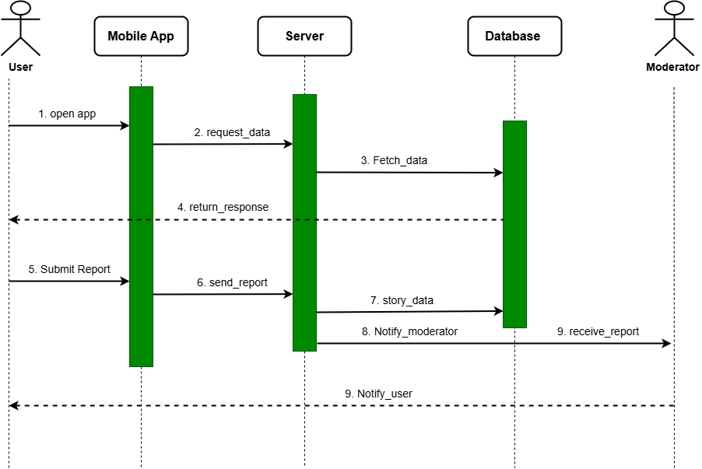
Figure 2.6
The sequence diagram shows the flow of events when a user interacts with the Citizen system. The process begins when the user opens the application and requests incident data. The mobile application communicates with the server, which retrieves relevant information from the database and sends it back to the user as alerts.
When a user submits a report, the data is sent to the server and stored in the database. The system then notifies moderators, who review the content to ensure accuracy before it is made visible to other users. This step is essential for maintaining the credibility of user-generated information.
The sequence also highlights continuous interaction between the user, server, and database, ensuring that information is updated in real time. This dynamic communication flow supports timely alerts and efficient incident reporting.

2.3.1.5. Features of the System
The Citizen Mobile Safety App provides real-time alerts based on the user’s geographic location, ensuring that users receive relevant information about nearby incidents. The system supports both official and user-generated reports, creating a comprehensive and dynamic source of safety information.
It includes multimedia capabilities such as live video streaming and photo sharing, allowing users to provide visual evidence of incidents. The system also integrates interactive maps for easy visualization of events and supports push notifications to keep users informed instantly (Rahman & Islam, 2023).
Additionally, the application incorporates content moderation features to verify reports and reduce misinformation. This combination of real-time alerts, user participation, and verification mechanisms enhances the overall effectiveness of the system.

2.3.1.6. Development Tools and Development Environment of the System
The Citizen Mobile Safety App is developed using modern mobile development frameworks that support cross-platform functionality for both Android and iOS devices. The system relies on a cloud-based backend infrastructure to manage large volumes of real-time data and user interactions.
It utilizes APIs for integration with external services such as mapping platforms and emergency data sources. The backend environment includes scalable cloud servers and databases that ensure high availability and efficient data processing.
Furthermore, the system incorporates real-time communication technologies such as push notification services and streaming protocols. These tools enable the application to deliver instant updates and support live content sharing, ensuring responsiveness and reliability.

2.3.2. Review of the Good Features
The Citizen Mobile Safety App excels in providing real-time, location-based alerts, which significantly improve user awareness of nearby incidents. This feature ensures that users receive timely and relevant information, enhancing personal safety and preparedness.
The inclusion of user-generated content and live streaming adds a dynamic dimension to the system, allowing real-time sharing of incident details. This enhances transparency and provides additional context that may not be available through official reports alone (Yeboah & Boateng, 2020).
Another strength of the system is its content moderation mechanism, which helps maintain data reliability. By filtering and verifying reports, the system reduces the spread of misinformation and ensures that users receive accurate and trustworthy information.

2.2.3. Review of the Bad Features
Despite its advantages, the Citizen Mobile Safety App faces challenges related to the reliability of user-generated content. Even with moderation, there is still a risk of misinformation or delayed verification, which may affect the accuracy of alerts.
The system also requires constant internet connectivity and access to smartphones, limiting its usability in areas with poor network infrastructure or low smartphone penetration. This can reduce its effectiveness in developing regions.
Additionally, privacy concerns may arise due to the use of location tracking and live video streaming. Users may be hesitant to share personal data or broadcast incidents, which could impact system adoption and participation (Sarker, 2021).

2.3.4. Summary of the System Review
In summary, the Citizen Mobile Safety App is a powerful tool for enhancing public safety through real-time alerts and community engagement. Its integration of location-based services, multimedia reporting, and content moderation makes it highly effective in providing timely and relevant information.
However, challenges related to misinformation, privacy concerns, and infrastructure dependency highlight the need for careful system design, especially in developing contexts. These limitations provide important insights for improving future systems.
The review of this system offers valuable guidance for the proposed project, particularly in incorporating real-time reporting, user interaction, and verification mechanisms while addressing issues of accessibility, reliability, and data privacy.

2.4 Review of System 1: Integrated Mobile Emergency System (with Dispatcher & Geolocation)

2.4.1. Description of the System

2.4.1.1. Overview of the System
The Integrated Mobile Emergency System is a research-based solution designed to improve emergency response through the integration of a mobile application for users and a web-based dispatcher system. The system enables users (victims or witnesses) to report emergencies directly through a mobile application, which automatically captures their geographic location using GPS technology. This information is then transmitted to a centralized server where it is processed and forwarded to emergency dispatchers for action (Adeyemi et al., 2023.
The system is structured to support real-time communication between users and emergency response teams. Unlike alert-only systems, this platform allows users to actively initiate emergency reports, making it highly suitable for environments where traditional reporting methods are inefficient. The dispatcher interface provides emergency personnel with detailed information about incidents, enabling faster decision-making and resource allocation.

2.4.1.2. Context Diagram for Integrated Mobile Emergency System

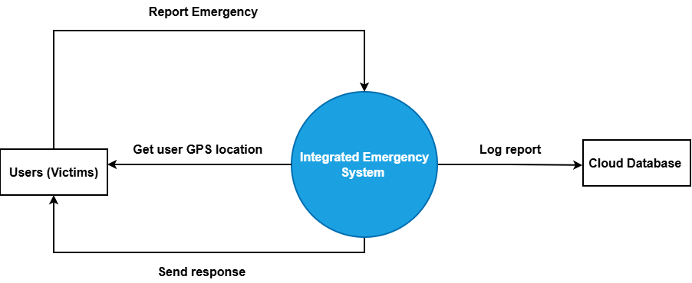
Figure 2.7
The context diagram illustrates the interaction between the Integrated Mobile Emergency System and external entities such as users, emergency responders, GPS services, and the dispatcher interface. The system acts as a central hub that receives emergency reports from users and processes them for dispatchers and responders.
Users initiate communication by submitting incident reports through the mobile application. The system then uses GPS services to capture accurate location data and stores the information in a cloud database. Dispatchers access this data through a web interface, analyze the situation, and coordinate response actions with emergency responders.
The diagram highlights the system’s role in bridging the communication gap between users and emergency services. All interactions pass through the system, ensuring proper data processing, storage, and controlled communication between all entities involved.

2.4.1.3. Use Case Diagram for Integrated Mobile Emergency System
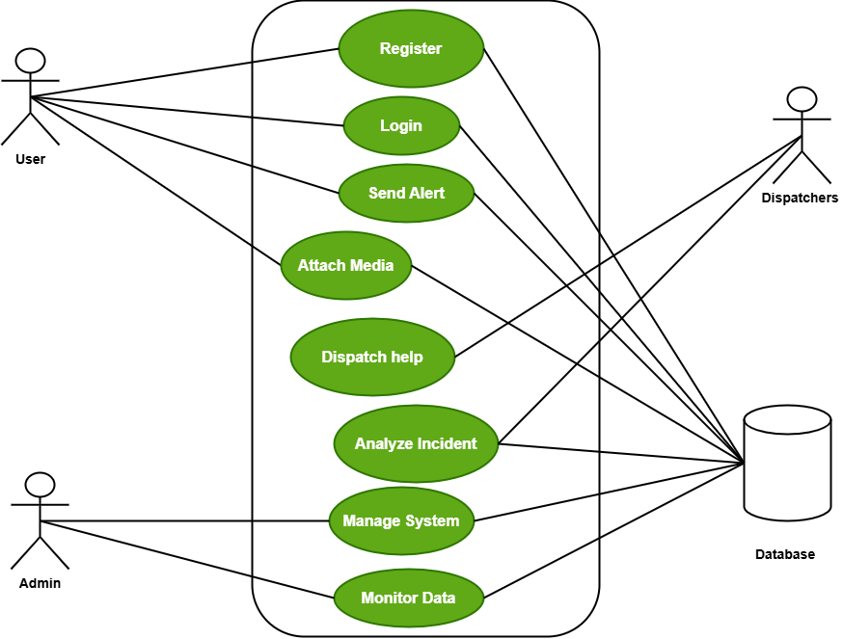
Figure 2.8
The use case diagram presents the interactions between the system and its primary actors: users, dispatchers, and administrators. Users interact with the system by registering, logging in, and submitting emergency alerts, often with additional media such as images or videos. They can also track the status of their reports.
Dispatchers play a central role by receiving alerts, analyzing incident details, and coordinating response actions. They also update the status of incidents, ensuring that users are informed about the progress of their reports. This interaction enhances transparency and communication between users and emergency services.
The administrator oversees the system by managing users and monitoring system performance. This ensures that the system remains functional, secure, and efficient. The diagram clearly shows how responsibilities are distributed among different actors to support effective emergency management.

2.4.1.4. Sequence Diagram for Integrated Mobile Emergency System

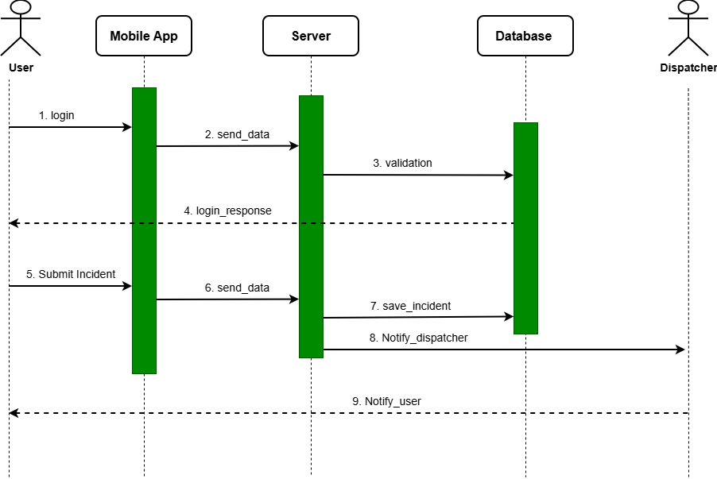
Figure 2.9
The sequence diagram illustrates the interaction flow when a user reports an emergency. The process begins when the user logs into the mobile application and submits an alert. The application sends the data to the server, which validates and stores it in the database.
Once the alert is processed, the system notifies the dispatcher, who reviews the incident details and determines the appropriate response. The dispatcher then updates the status of the incident, which is communicated back to the user through the system.
This sequence demonstrates real-time communication and coordination between users, the backend system, and dispatchers. It highlights how the system ensures efficient data flow, quick response, and continuous feedback to users.

2.4.1.5. Features of the System
The Integrated Mobile Emergency System enables users to report emergencies in real time using a mobile application that automatically captures GPS location data. This ensures accurate and timely reporting of incidents, reducing delays caused by unclear location information.
The system supports multimedia attachments such as images and videos, allowing users to provide additional context for emergency situations (Smith & Chen, 2021). It also includes a dispatcher interface that enables emergency personnel to analyze reports, coordinate responses, and update incident status.
Additionally, the system provides feedback to users by allowing them to track the status of their reports. This improves transparency and user confidence in the system while enhancing communication between users and emergency service providers (Rahman & Islam, 2022).

2.4.1.6. Development Tools and Development Environment of the System
The system is developed using mobile application frameworks that support Android platforms, combined with web technologies for the dispatcher interface. The backend is built using server-side programming languages and frameworks that handle data processing, authentication, and communication between components.
It utilizes APIs to integrate GPS services for location tracking and cloud-based databases for storing user and incident data. The development environment includes tools for both mobile and web development, ensuring seamless interaction between the user application and dispatcher system.
The system also employs cloud infrastructure to ensure scalability, reliability, and real-time data processing. This allows it to handle multiple users and emergency reports simultaneously without performance issues.

2.4.2. Review of the Good Features
The system provides a comprehensive approach to emergency reporting by allowing users to actively submit incidents rather than relying solely on alerts. This makes it highly suitable for regions where emergency reporting infrastructure is limited.
The integration of GPS technology ensures accurate location tracking, which is critical for reducing response times. The inclusion of a dispatcher interface further enhances coordination by enabling emergency personnel to analyze and respond to incidents effectively.
Another strength of the system is its feedback mechanism, which allows users to track the status of their reports. This improves transparency and builds trust between users and service providers (Smith & Johnson, 2021).

2.4.3. Review of the Bad Features
One limitation of the system is its reliance on internet connectivity for real-time reporting and communication. In areas with poor network coverage, users may experience delays in submitting reports or receiving updates.
The system may also require significant technical infrastructure, including servers and dispatcher interfaces, which could be costly to implement and maintain. This may limit its adoption in resource-constrained environments (Subashini & Kavitha, 2020).
Additionally, the system depends on user participation and accurate data entry. Incorrect or incomplete information from users may affect the quality of reports and hinder effective emergency response.

2.4.4. Summary of the System Review
In summary, the Integrated Mobile Emergency System offers a robust solution for real-time emergency reporting and response coordination. Its combination of mobile reporting, GPS tracking, and dispatcher integration makes it highly effective in improving communication and response efficiency.
However, challenges such as reliance on internet connectivity, infrastructure requirements, and data accuracy must be considered when implementing the system in developing regions. These limitations highlight areas for improvement in future system design.
The system provides valuable insights for the proposed project, particularly in integrating user reporting, geolocation, and dispatcher coordination while ensuring accessibility, scalability, and ease of use.

References
PulsePoint Foundation. (2023). PulsePoint Respond Overview. Retrieved from https://www.pulsepoint.org
Citizen App. (2023). Citizen: Real-Time Safety Alerts. Retrieved from https://citizen.com
Lamothe, J., Mensah, K., & Adu, P. (2021). Mobile technologies in emergency communication systems. International Journal of Emergency Management, 17(2), 144–160.
Adeyemi, T., & Salami, K. (2021). Mobile-based incident reporting in African communities. Journal of Mobile Technology, 12(3), 89–104.
Rahman, M., & Islam, R. (2023). Mobile reporting systems for urban infrastructure management. Journal of Cloud Computing, 12(1), 88–101.

